
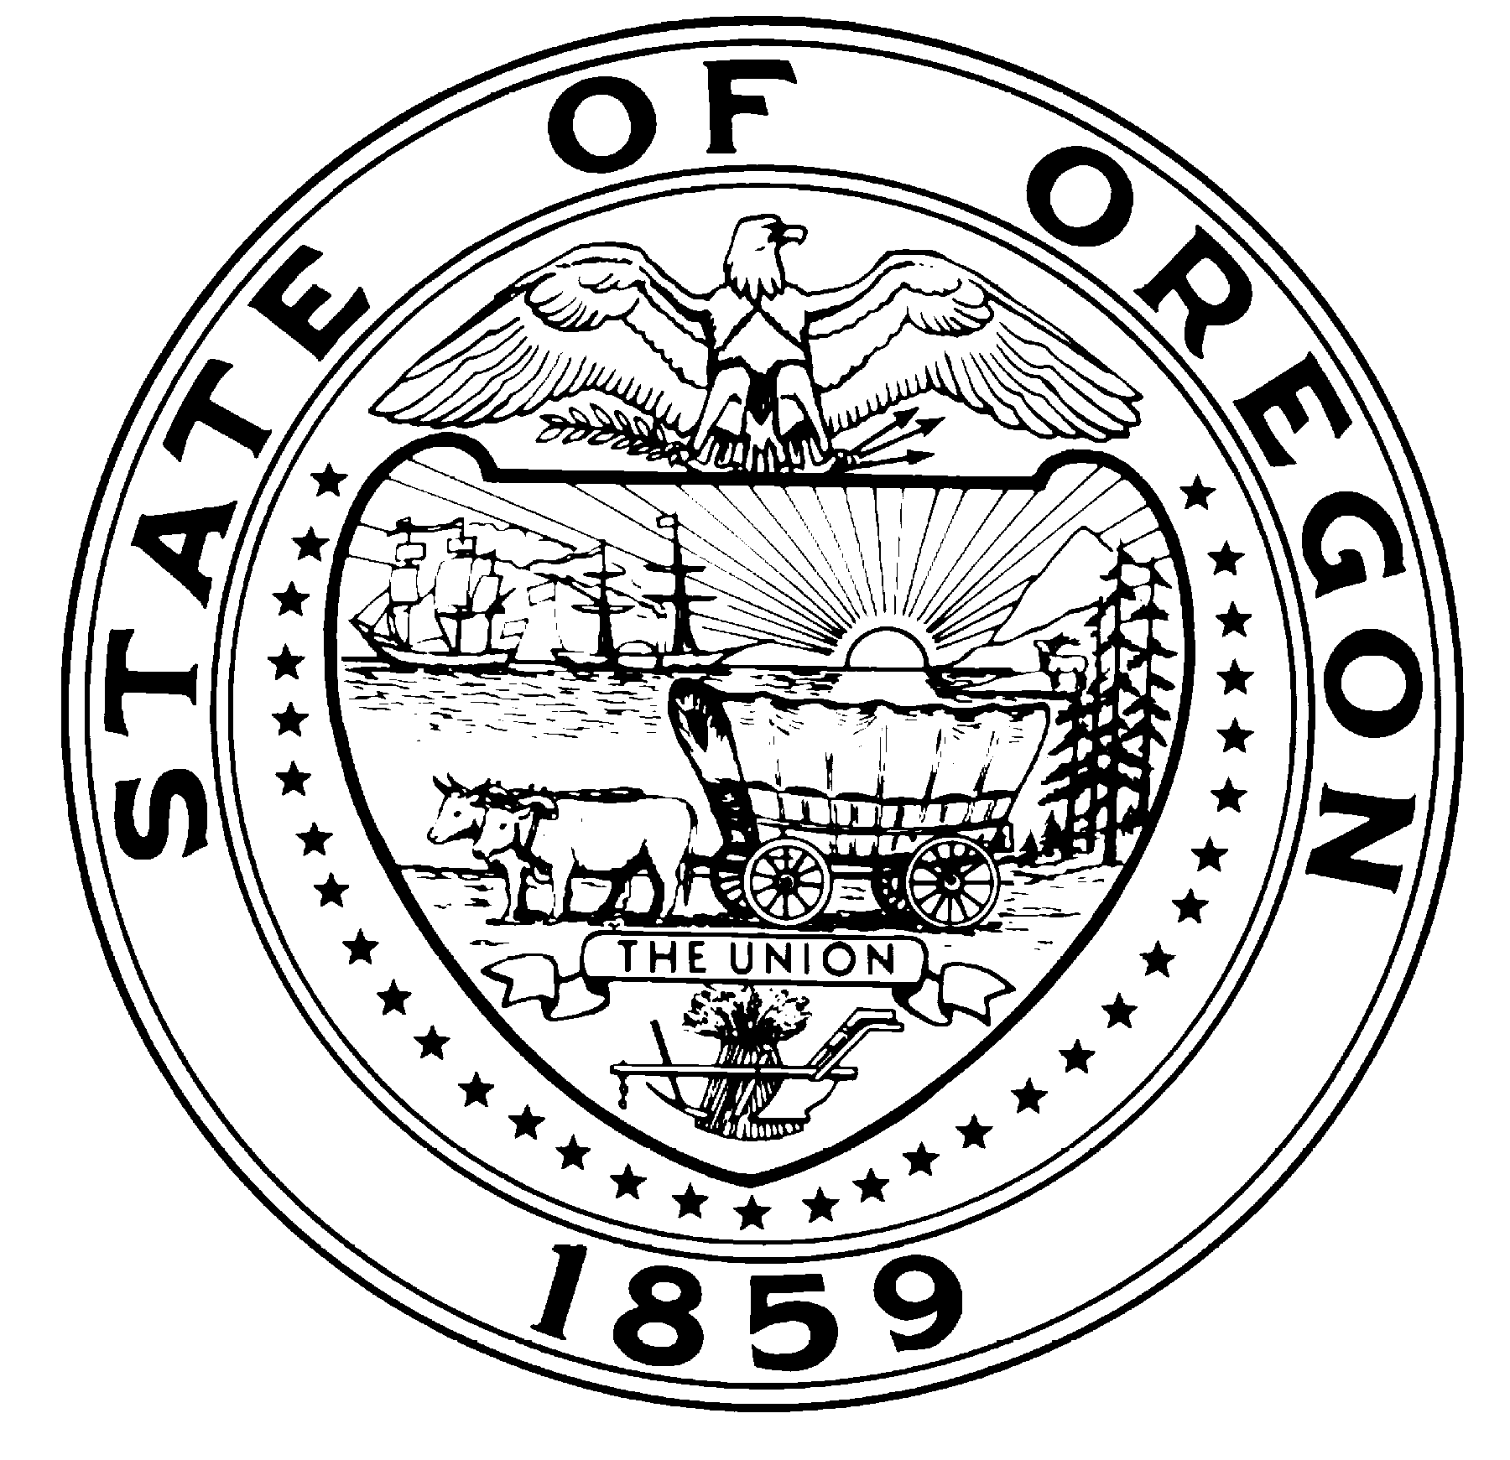
John A. Kitzhaber, MD, Governor

State Library
250 Winter St. NE
Salem, OR 97301-3950
(503) 378-2464
FAX (503) 585-8059

CONTACT: MaryKay Dahlgreen
Oregon State Library
Marykay.Dahlgreen@state.or.us
503-378-4367

DATE, 2014

FOR IMMEDIATE RELEASE:

The Ready to Read Grant Program’s 20th Anniversary

Has your child participated in the summer reading program at a public library? Have you taken your child to a storytime at a public library? If you have, then your family has most likely benefited from the Ready to Read Grant program.

In 1992 a report to the Joint Interim Committee on Education recommended that the State Library re-direct the state general funds that came to local public libraries be targeted on the purpose of improving library services to children. During the 1993 Legislative Session Oregon Revised Statutes 357.740-357.780 became law, creating the Ready to Read Grant program. The law required public libraries to use their Ready to Read Grant (i.e. state funds) to establish, develop or improve public library services to children ages 0-14 and report how they spent the money. In 2006 the law was revised to focus the Ready to Read Grant on early literacy and the summer reading based on research that shows the experiences children have before they start school and later during summer vacation has the greatest impact on the achievement gap .

For the past 20 years Oregon public libraries have dedicated all of the state general fund they receive through the Ready to Read Grant program to provide the materials, programs, and services that help children develop the literacy skills they need to be ready for kindergarten and maintain their reading skills over the summer. Last year $609,801 was distributed among 130 libraries. The average grant award received by libraries was $4,727 and there is a minimum grant of $1,000v. As a result of these funds being invested in library youth services:
- Attendance at children’s literacy program at public libraries increased from 488,380 people in 1994 to 1,187,773 people in 2013.
- Participation in the public library summer reading program has increase from 116,570 children in 2006 to 189,430 children in 2013.
- Last year 544,521 children had access to a public library that implemented all three youth services best practices compared to 437,002 children in 2006.

Public libraries now report the impact these literacy program have on children in their community to the State Library. Here are a few examples of how children improved their literacy skills by participating in public library literacy programs in 2012-2013.
- Nyssa Public Library reported that children participating in storytimes gradually extended their attention span and developed the early literacy skills necessary for participating in storytime activitiesv.
- Silver Falls Library District surveyed parents/caregivers of children who participated in early literacy program and reported that 81% of children increased their ability to recognizes letters (letter knowledge) and 91% increased their ability to sing or recite rhymes (phonological awareness)v.
- Yachats Public Library surveyed parents/caregivers of children who participated in the summer reading program and reported that 80% of children increased the amount they read and 100% of children improved their reading/listening comprehensionv.

The State Library would like to thank public libraries for implementing the Ready to Read Grant program effectively in communities across the state for the past 20 years and encourage you to thank your librarian for their contribution to your child’s literacy development.

########

Alexander, K.L. (2009). Summer Can Set Kids on the Right—or Wrong—Course (Research in Brief). Retrieved from http://c.ymcdn.com/sites/www.summerlearning.org/resource/collection/CB94AEC5-9C97-496F-B230-1BECDFC2DF8B/Research_Brief_02_-_Alexander.pdf
Jumpstart. (September 2009). America’s Early Childhood Literacy Gap. Retrieved from http://www.lumeinstitute.org/wp-content/uploads/2011/03/Americas_Early_Childhood_Literacy_Gap.pdf
? Oregon State Library. 1993-1994 and 2012-2013 Oregon Public Library Spreadsheets (Annual Statistics). Retrieved from http://www.oregon.gov/osl/LD/Pages/statsploregon.aspx
? Oregon State Library. (2013). Summer Reading Brief 2013. Retrieved from http://www.oregon.gov/osl/LD/youthsvcs/srp.certificates/OSLsrpBrief2013-Final.pdf
? Oregon State Library. (2014). Ready to Read Grant Program: 2012-2013 Annual Report. Retrieved from http://www.oregon.gov/osl/LD/youthsvcs/ReadytoRead/R2RannualReport2012-2013-FINAL.pdf

