

President’s Report
OLA Information, 20__- 20___

Executive Board Officers

President:
Vice President:
Past President:
Treasurer:
Secretary:
ALA Chapter Councilor:
Member at large:
ACRL Chair:
CSD Co-Chairs:
OASL Chair:
OYAN Chair:
PLD Chair:
REFORMA Oregon Chair:
SSD Chair:
Parliamentarian:
State Librarian:
Association Manager:

Location and theme of annual conference

City:
Hotel:
Dates:
Theme:

Notable speakers:

Notable awards/honorary memberships

President’s Award
President’s Accomplice Award (optional):
Distinguished Service Award:
OLA Legislator of the Year:
OLA Librarian of the Year:
Library Employee of the Year:
Library Supporter of the Year:
Honorary Life Membership:
Intellectual Freedom Committee Award:
Evelyn Sibley Lampman Award:
Pearl Award:

Legislative activity

Outstanding Events:

Unit Activity (optional)


- ACRL-OR

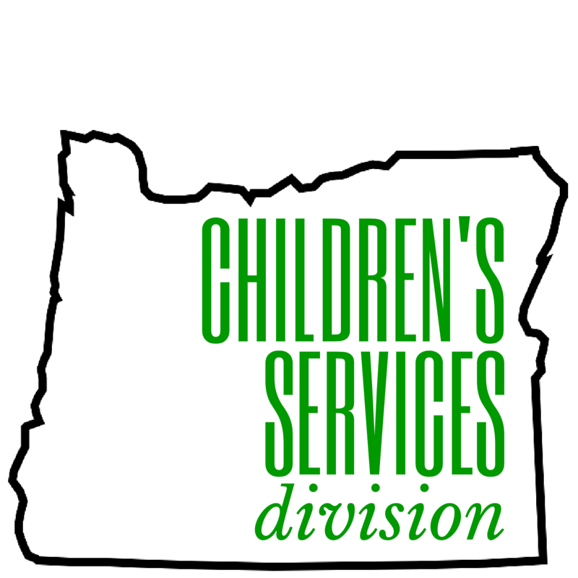
- CSD


- OASL


- OYAN


- PLD


- SSD


- REFORMA OR


- EDI Anti-Racism Committee


- IFC

- Leadership


- Oregon Author’s

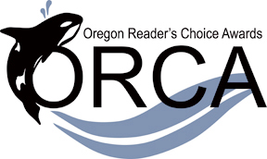
- ORCA

- Technical Services Round Table (TSRT)

- Staff Training Round Table (STRT)

