






WELCOME
TO YOUR LIBRARY
The library card grants you access to available materials such as books, movies, CD music and more. You can use the card to:
Check out materials from your library
Place holds from other libraries
To use the available public computers with Internet access

You must check out the materials at the circulation desk with your library card before you take them home.

How to use your library card
Library Name Here
Encouraging everyone to read

Tel: 555 555 5555
Library Name Here
Your Address Line 2
Your Address Line 3
Your Address Line 4

Phone: 555-555-5555
Fax: 555-555-5555
E-mail: someone@example.com
Logo Here
How to use
the library
Monday [library hrs for Mon. here]
Tuesday [hrs for Tues. here]
Wednesday [Lib. hrs for Wed. here]
Thursday [hrs for Thurs. here]
Friday [Library hrs for Fri. here]
Saturday [Library hrs for Sat. here]
Sunday [Library hrs for Sun. here]

Library Hours


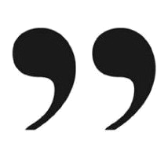

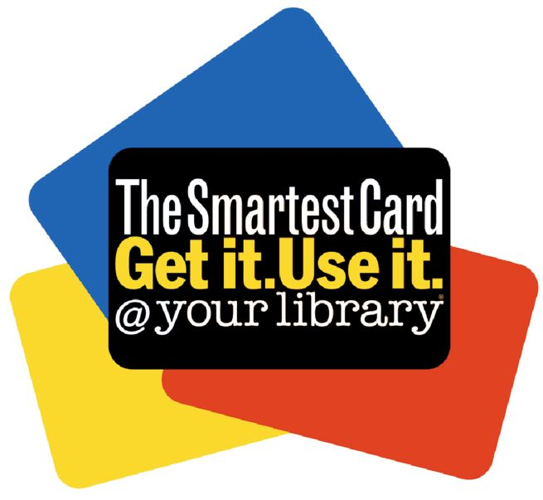
Reading is the tool for living a good life.
Library cards are free for those that live within city limits of your home library.
To apply for a library card you must do the following:
Fill out a library registration form
Provide identification and verification of your current home address to verify if you live within city limits
If you live outside the city limits, an annual fee applies. Special cards are available for children and young adults. Scholarships may be available, call or visit your library for more information.
Check Out Limits
You may check out as many items as the library card allows. Please find out what the check out limits are for your library. You can borrow the materials for an allotted amount of time. You must return the items before or on the due date indicated; otherwise the library will charge you overdue fines for each item and for each day that passes.
When you check out the items, you will be handed a receipt that lists each item and their due dates.
Where to Return Items
The library has designated slots where you can return library materials which may be located inside or outside the building. Inside the library, it’s common to find the return slots by the entrance or by the circulation desk. Some libraries have bins placed outside the building where you can also return the items.
Lost Cards
You can replace lost cards. It may be possible that charges apply when replacing a card. You will need to show identification.
How to Renew Items
If you would like to keep library item for a longer period of time, you may renew the due date. You can renew items by calling the library, in person or some libraries allow you to do it online. There are certain items that you may not be able to renew. If you renew overdue items, your account will be charged a fee for each item and each day that passed up to the date of renewal.
Fees
Most of the library services are free, but a charge applies when items borrowed are overdue, damaged or never returned. A fee is charged for each item checked out and for every day the due date passes. Fees stop when the item is returned or the due date is renewed.
Damaged/Lost Items
Please do not mark or damage the item. If this happens, return the item to the library and the damage will be assessed. A fee will be charged for the repair of the item. The library will inform you if the item cannot be repaired and charge you the cost of replacing the item. For lost items, the library will charge the cost of replacing it.
How to Apply for a
Library Card

